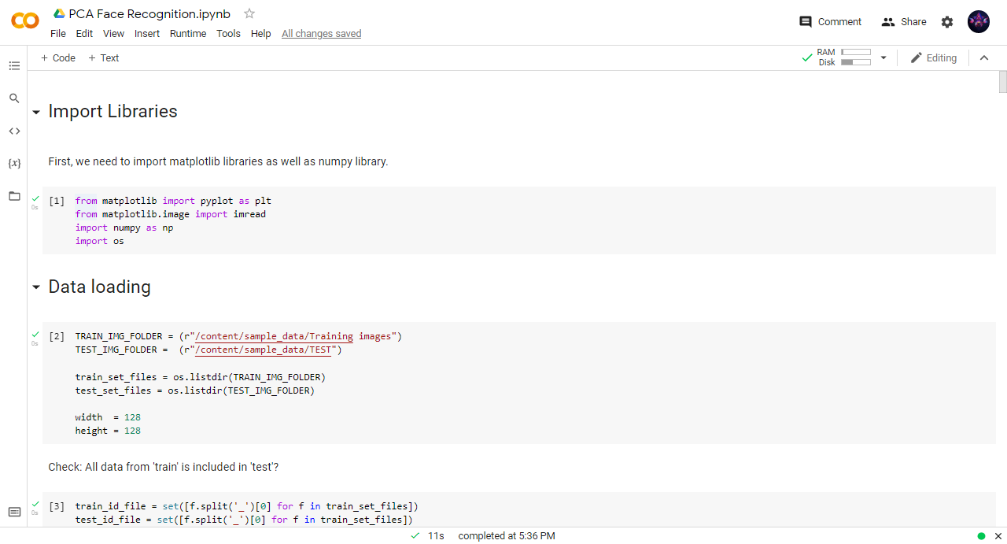

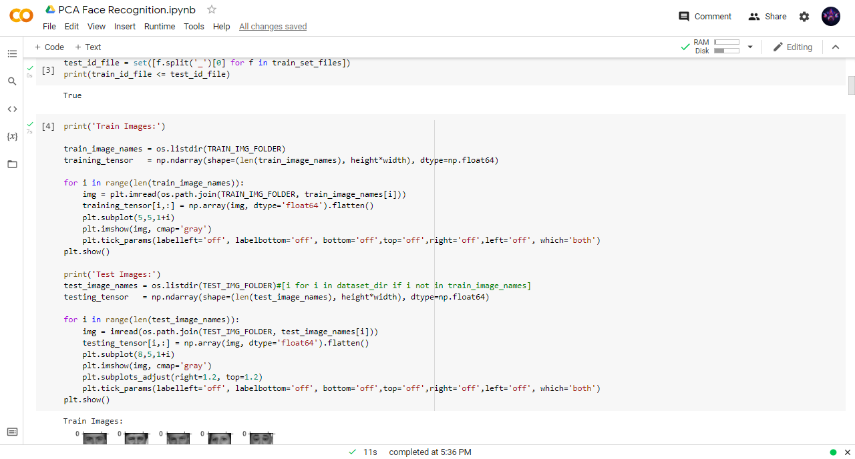

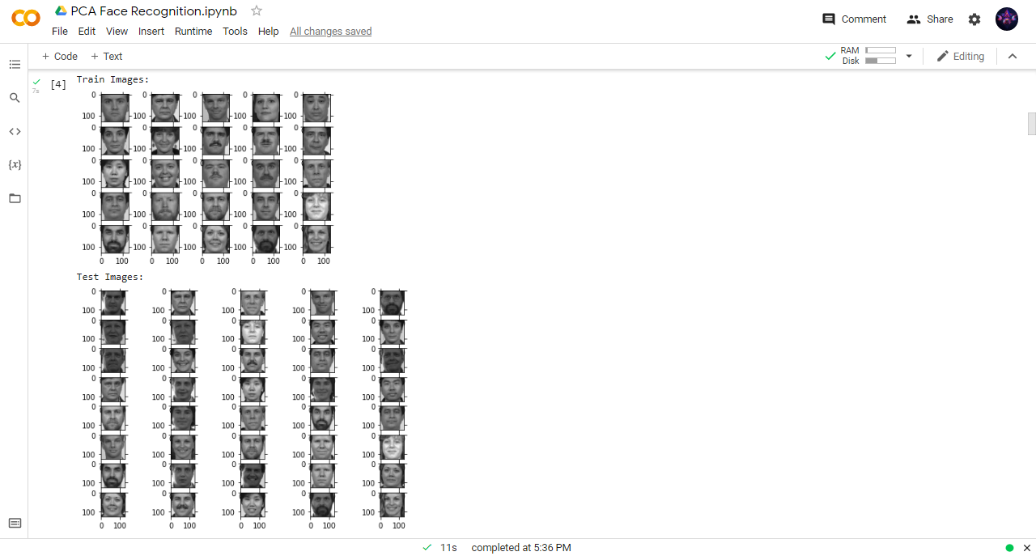

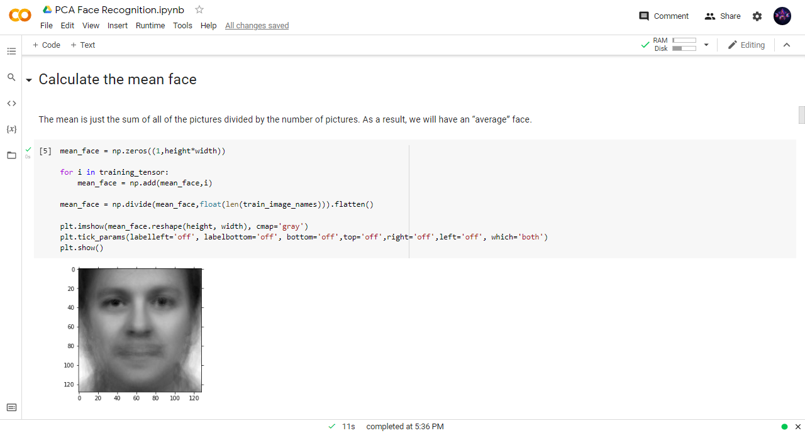

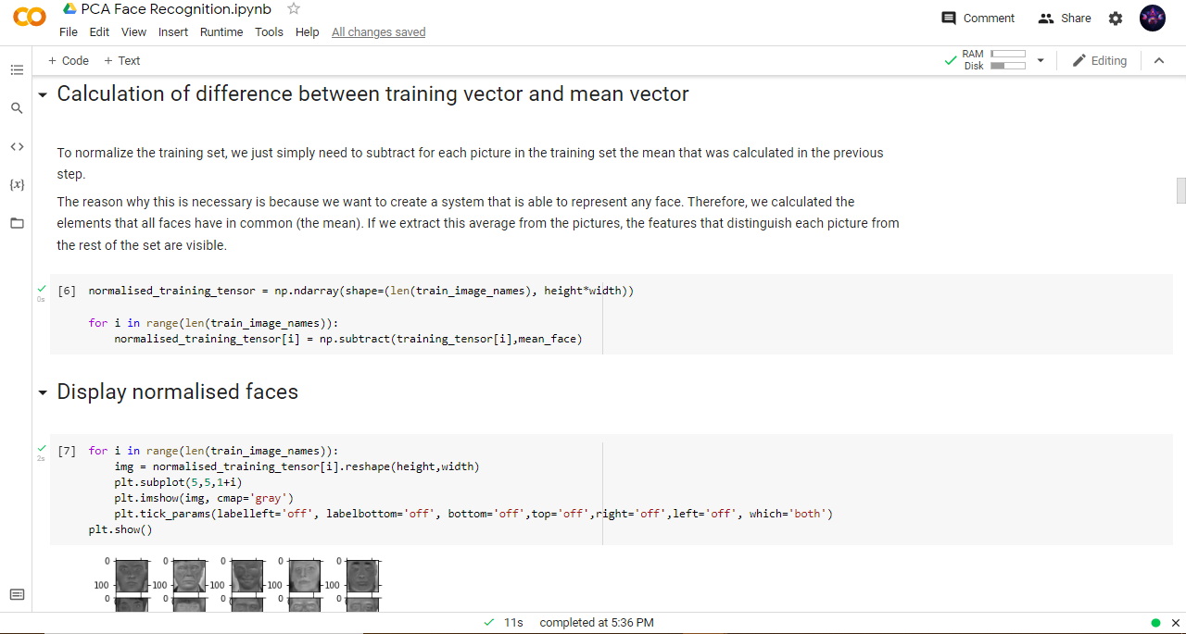

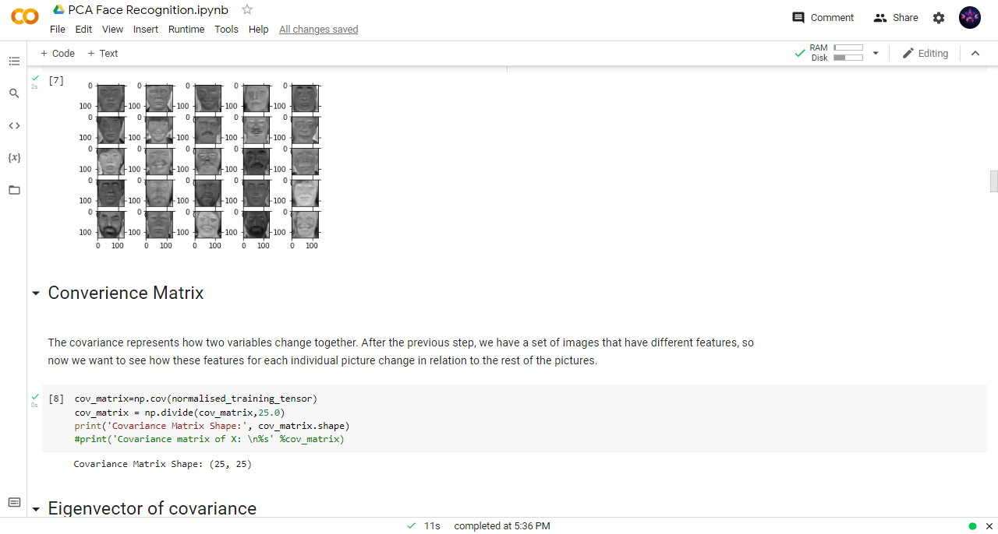

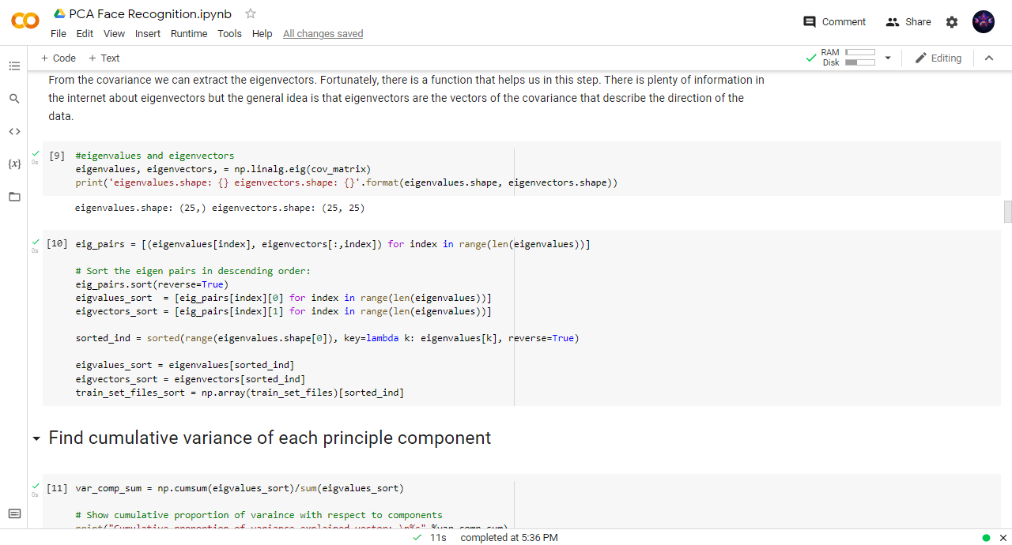

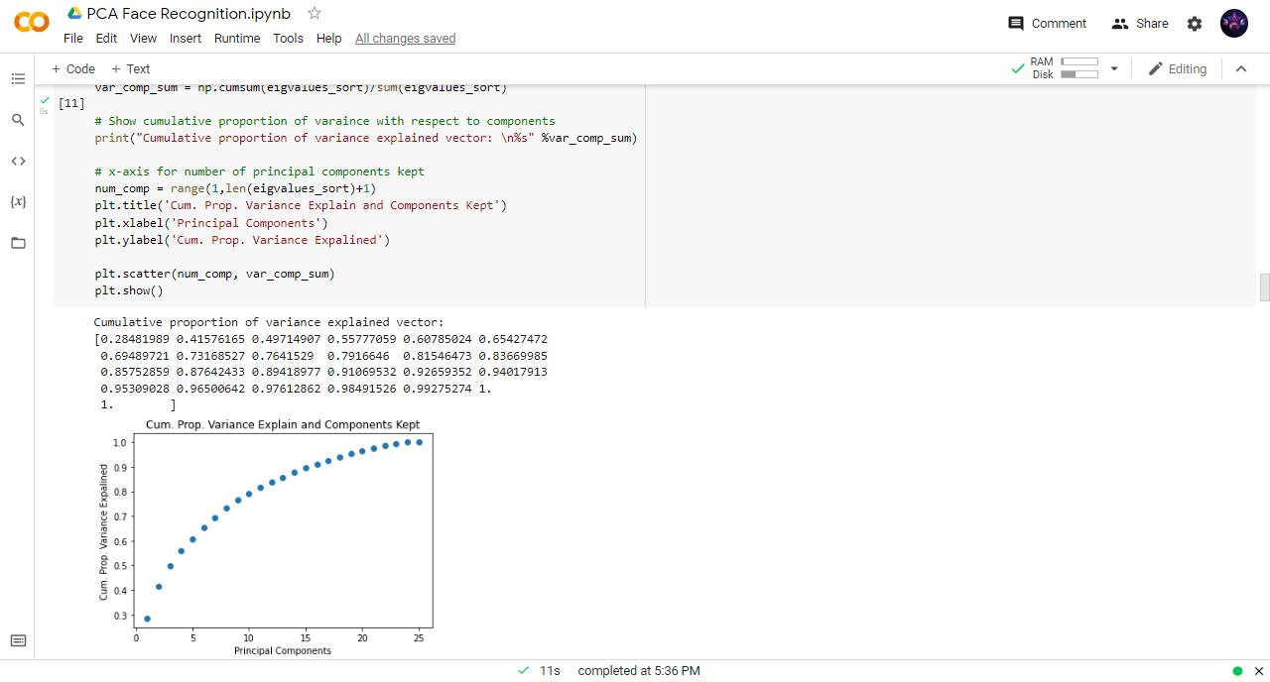

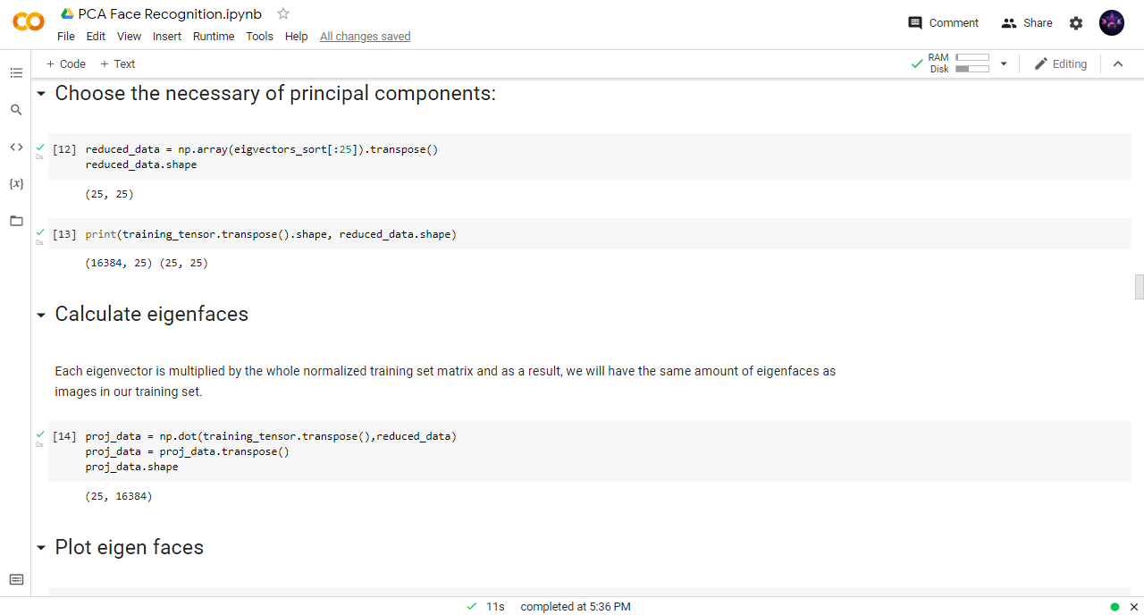

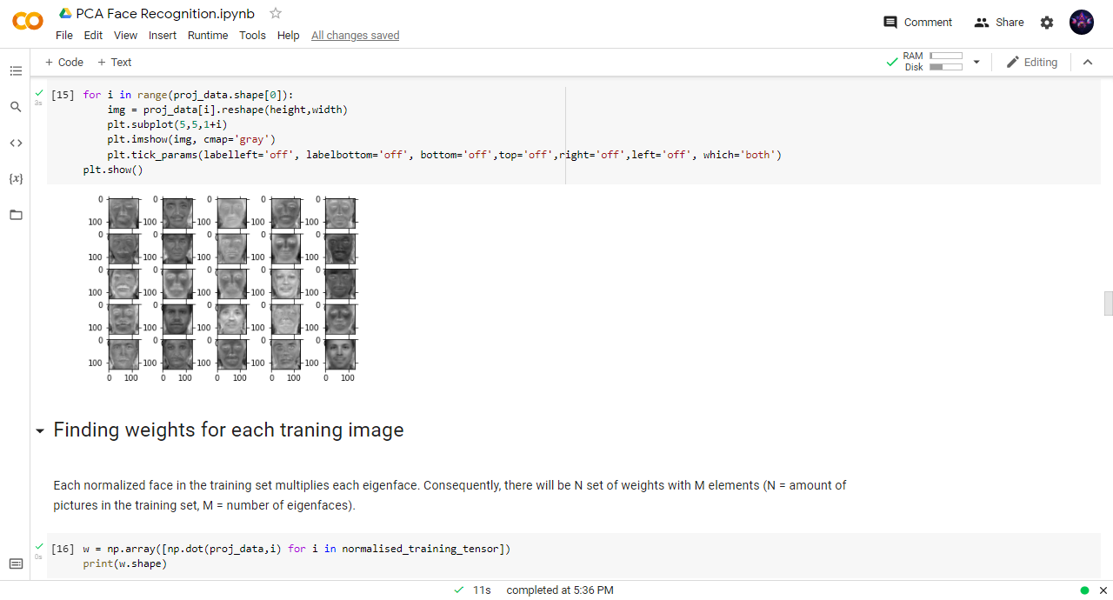

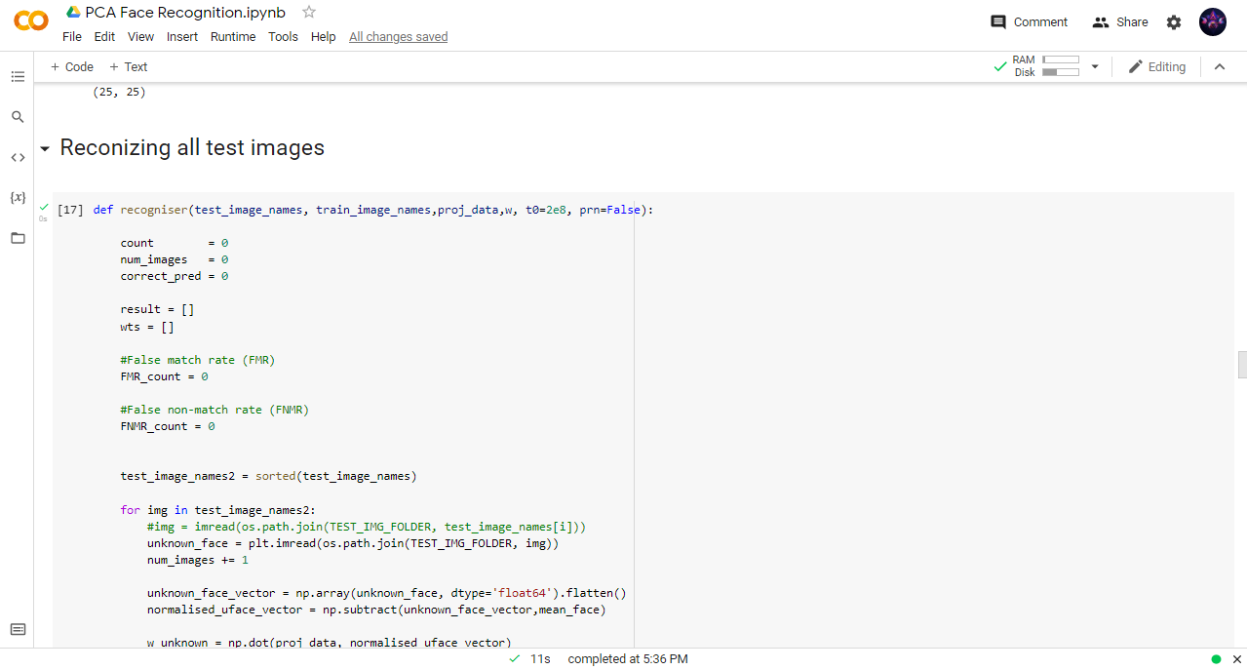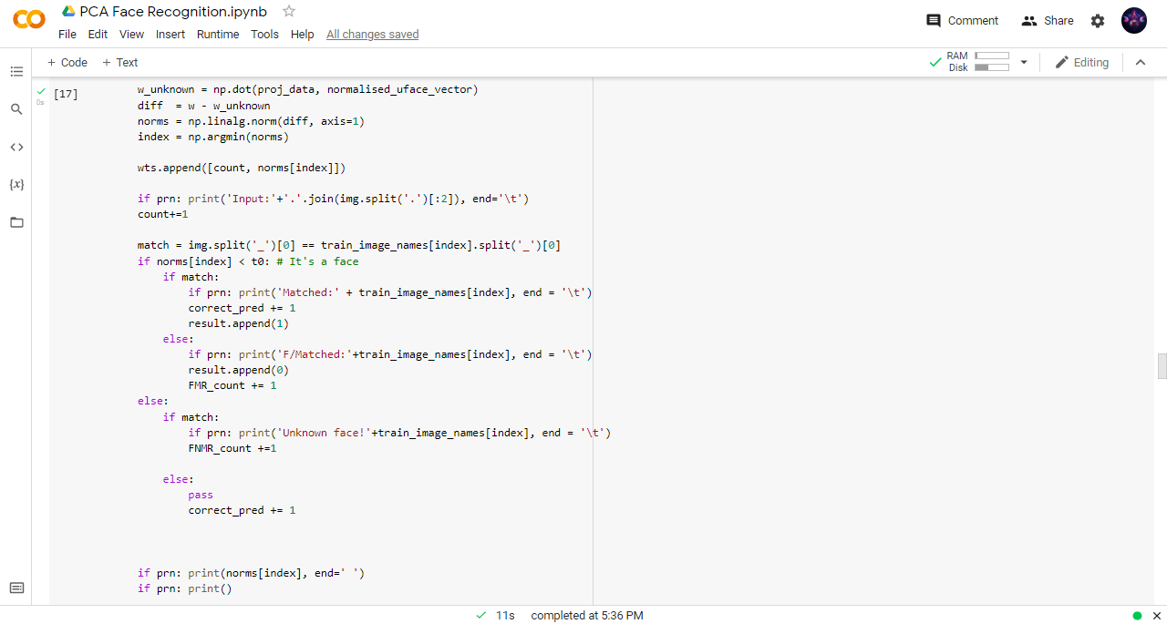

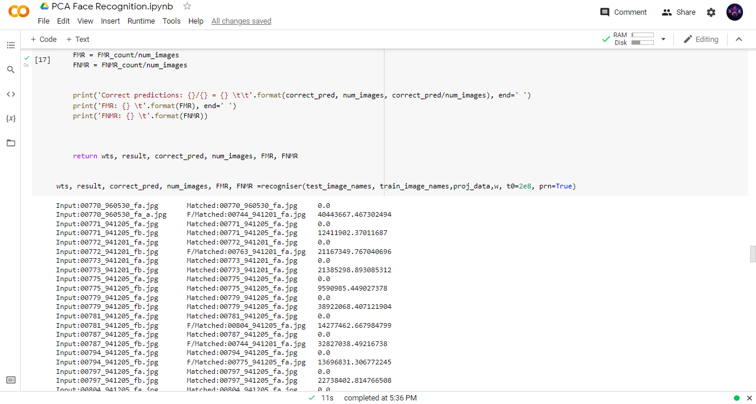

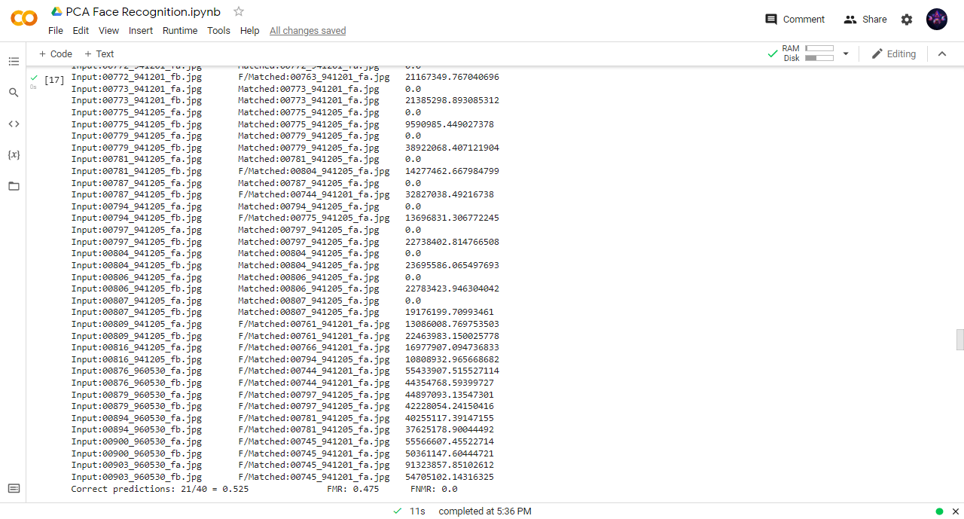

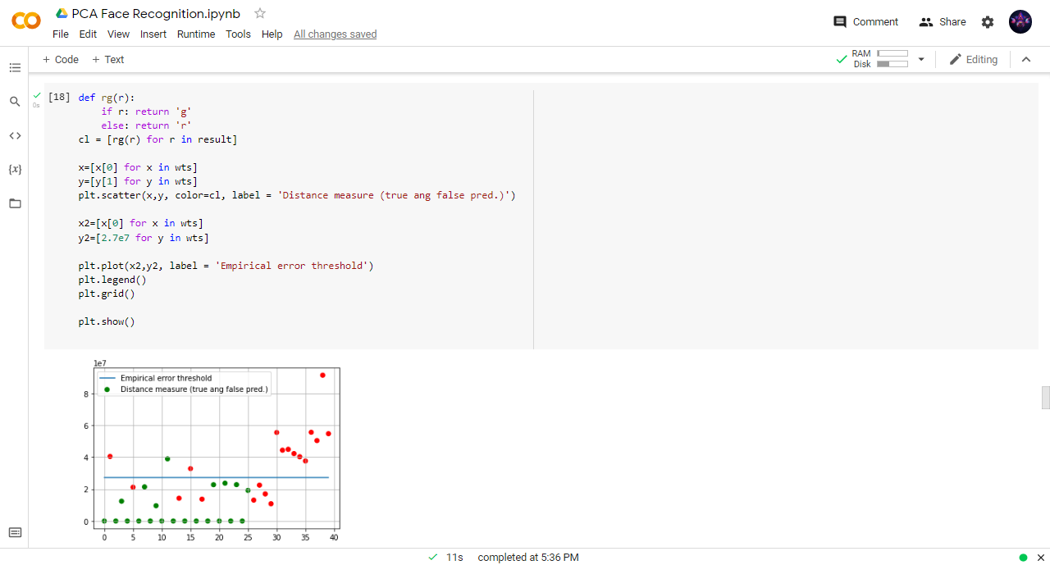

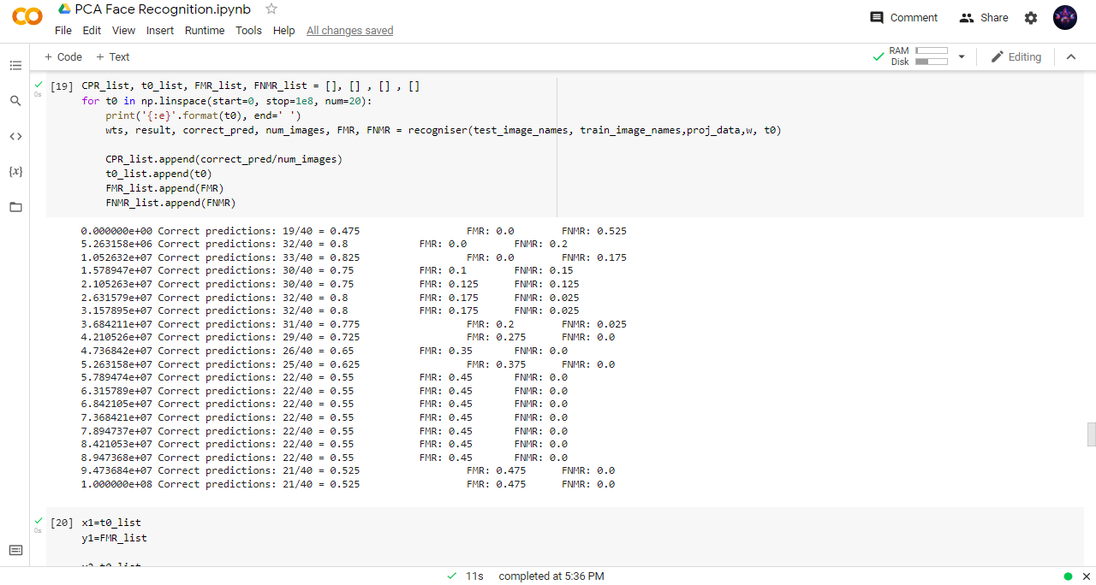

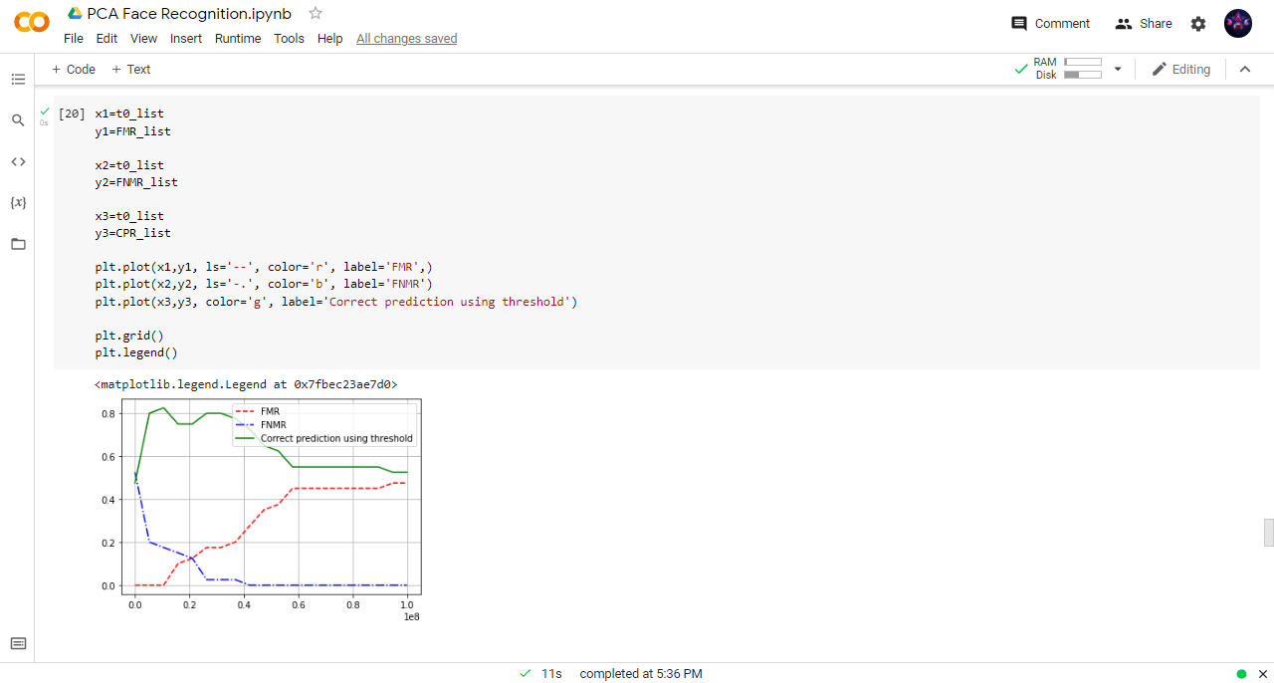

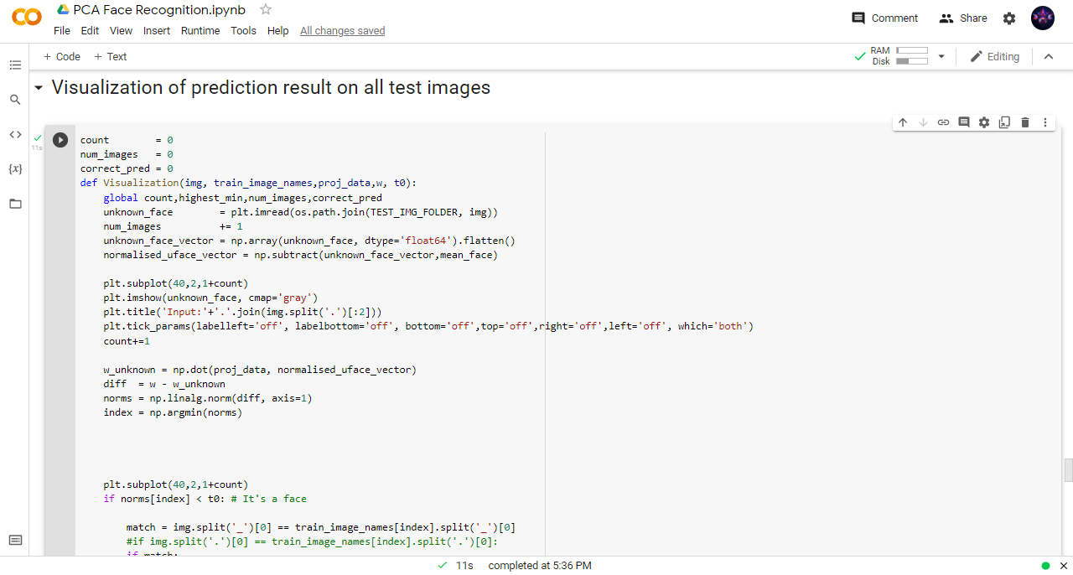

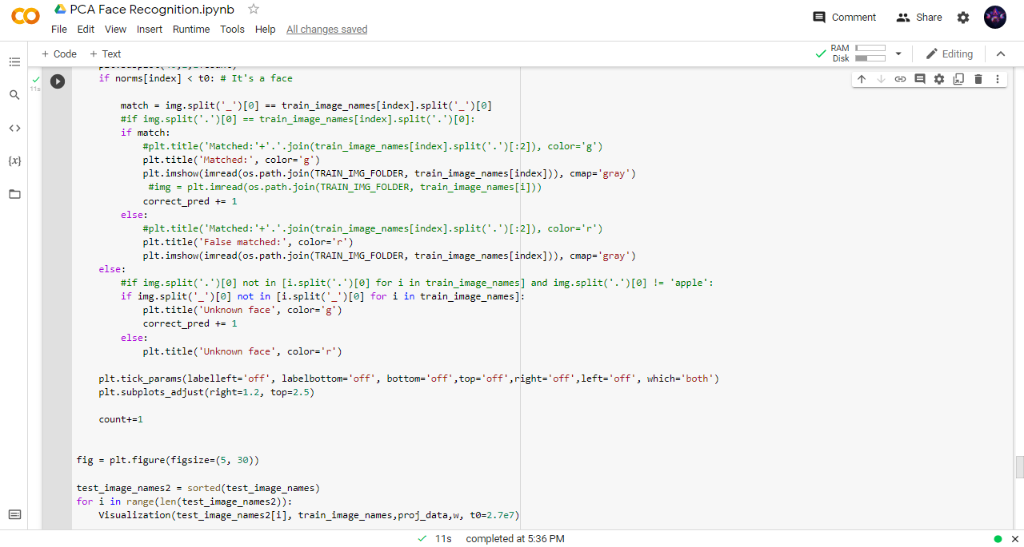

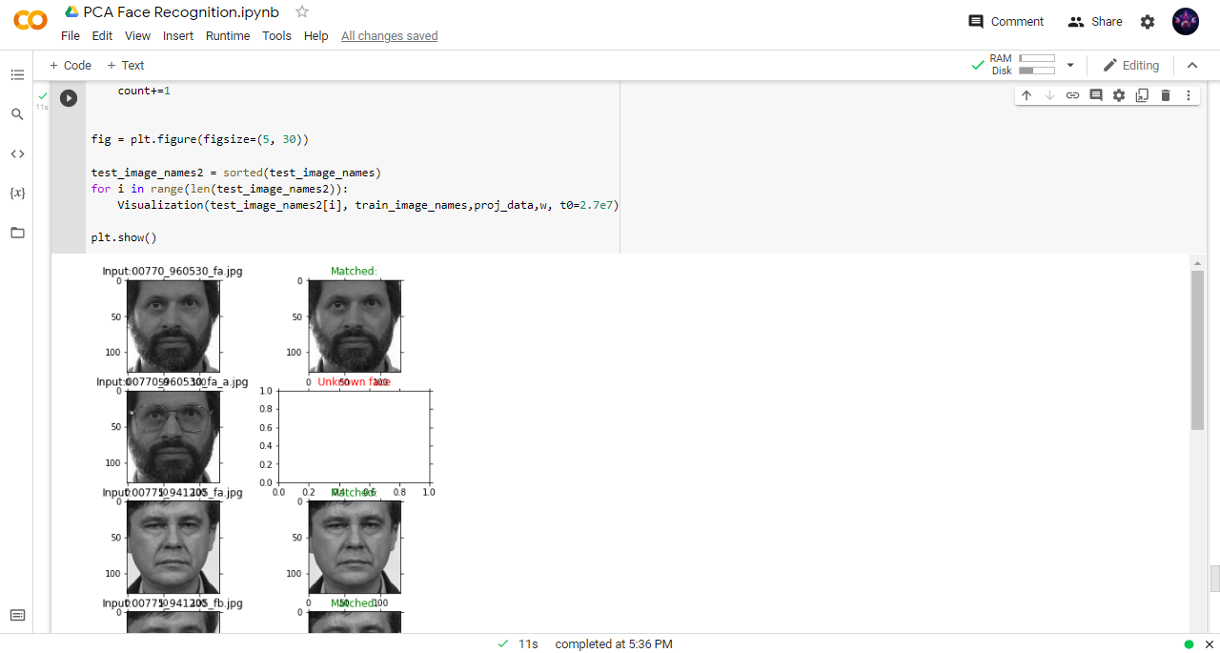

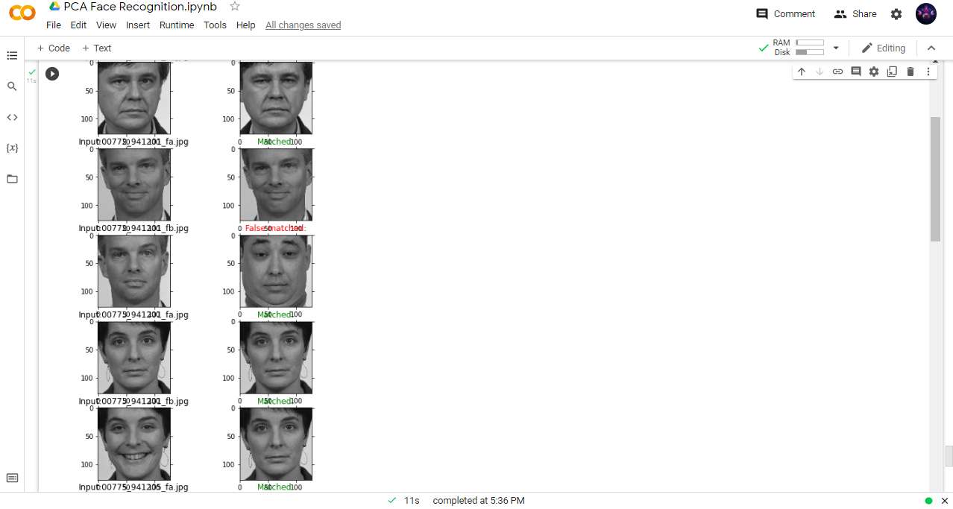

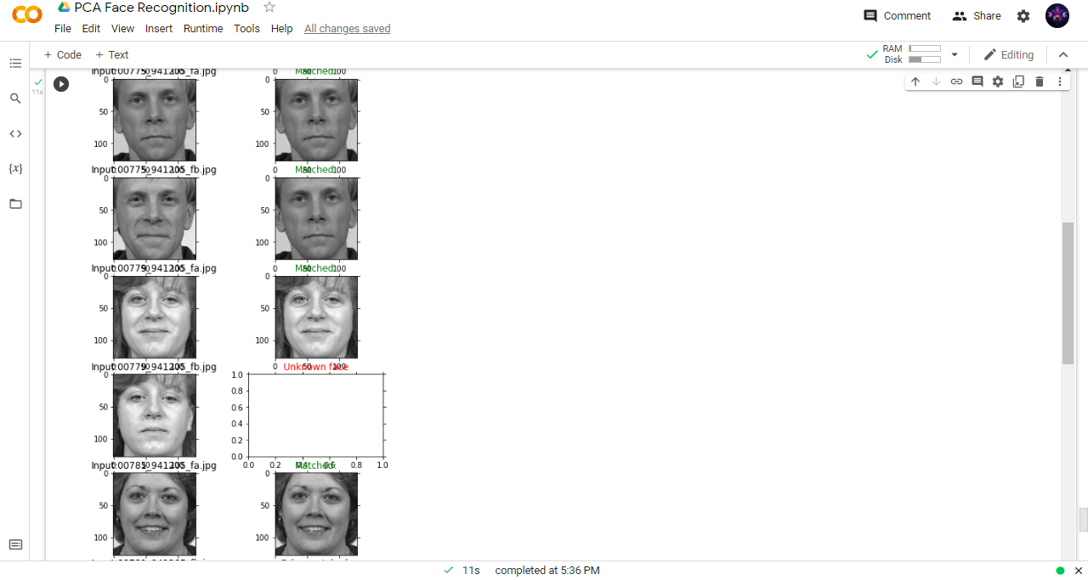

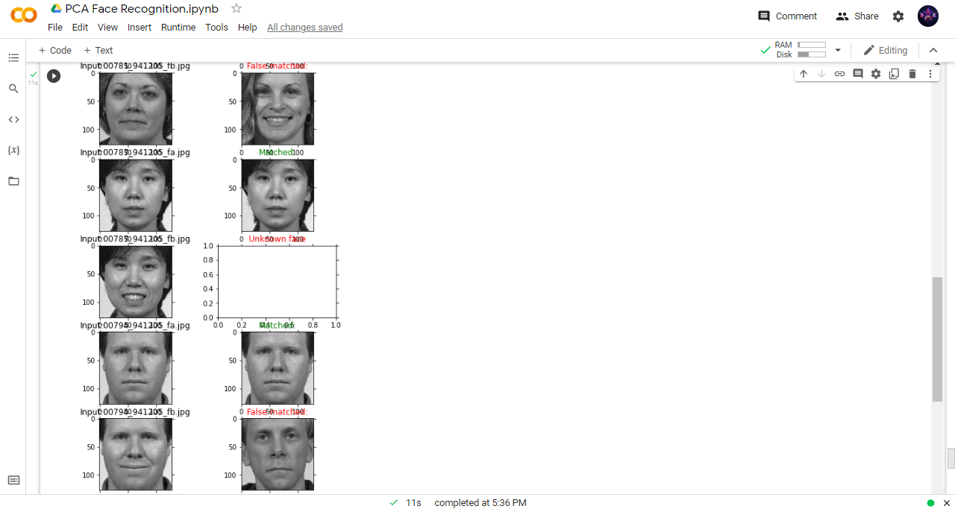

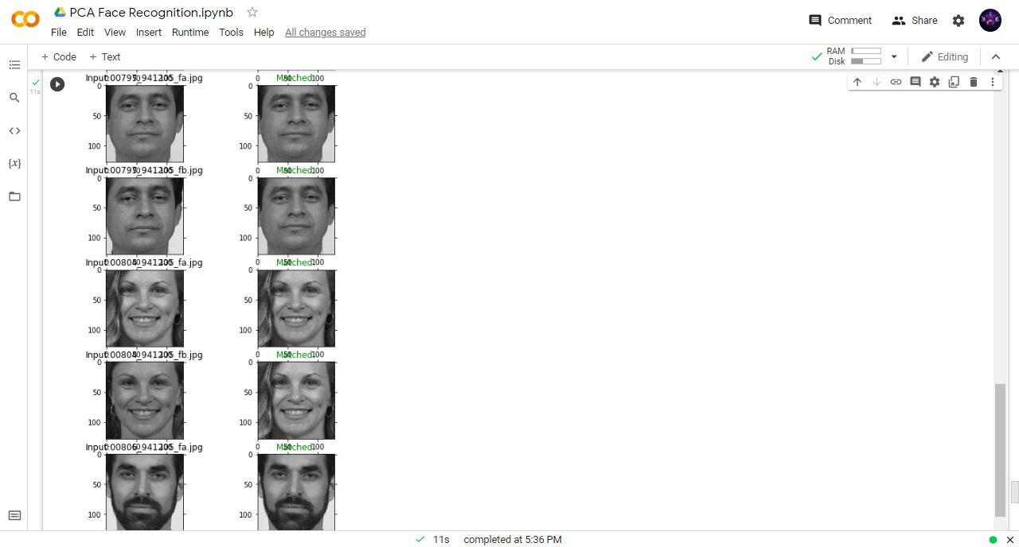

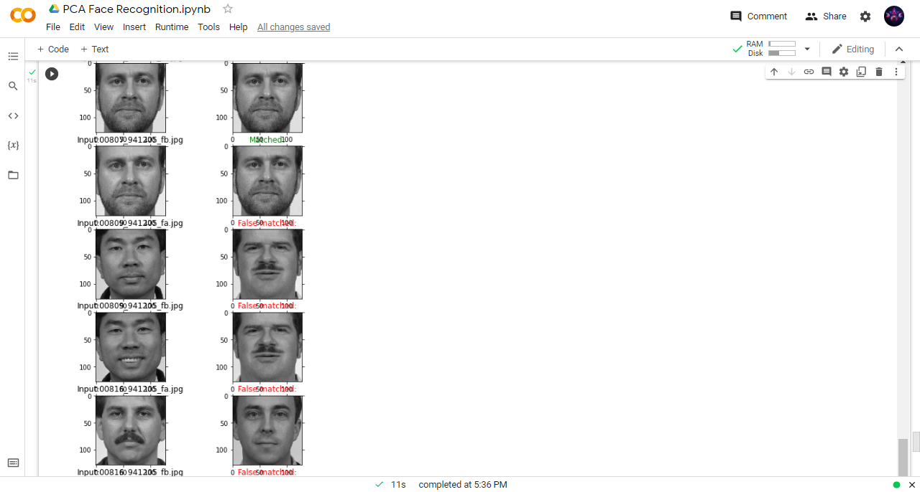

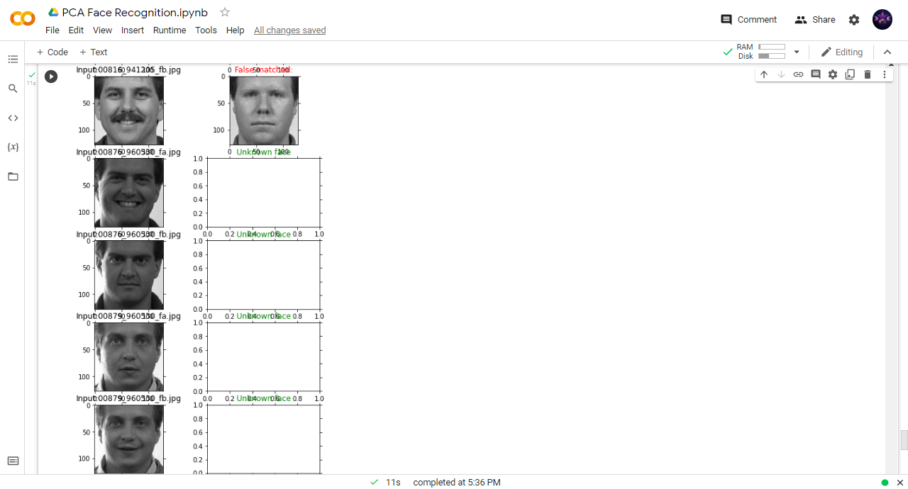

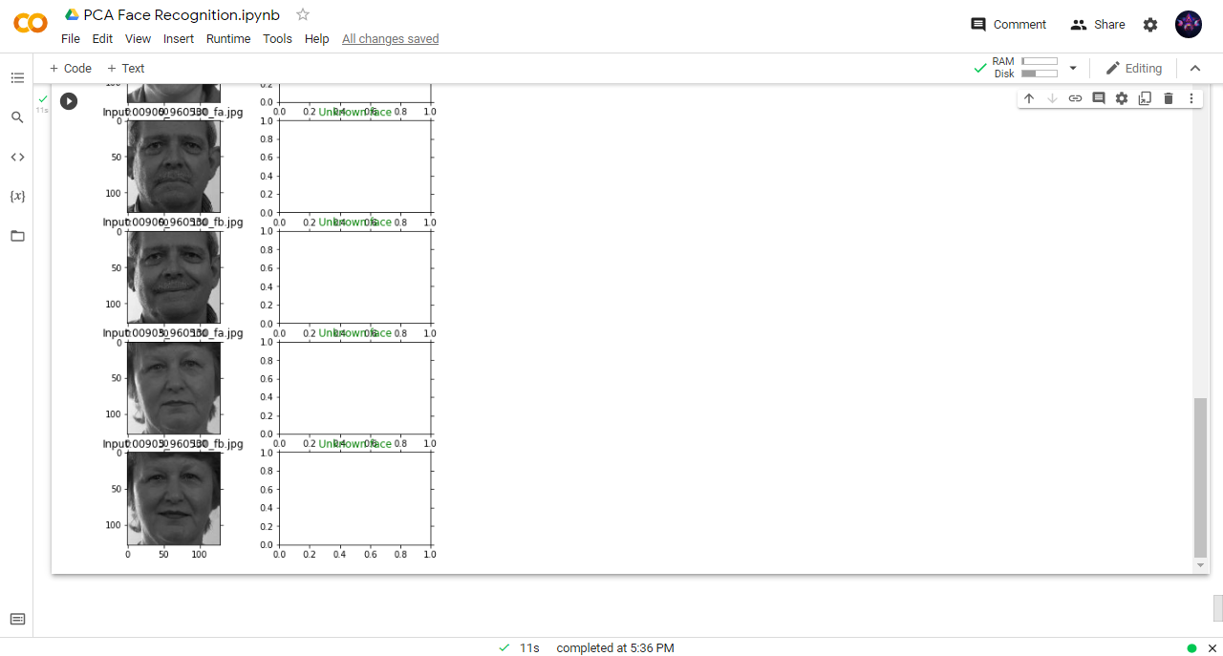

from matplotlib import pyplot as plt

from matplotlib.image import imread

import numpy as np

import os

TRAIN_IMG_FOLDER = (r"/content/sample_data/Training images")

TEST_IMG_FOLDER =  (r"/content/sample_data/TEST")

train_set_files = os.listdir(TRAIN_IMG_FOLDER)

test_set_files = os.listdir(TEST_IMG_FOLDER)

width  = 128

height = 128

train_id_file = set([f.split('_')[0] for f in train_set_files])

test_id_file = set([f.split('_')[0] for f in train_set_files])

print(train_id_file <= test_id_file)

print('Train Images:')

train_image_names = os.listdir(TRAIN_IMG_FOLDER)

training_tensor   = np.ndarray(shape=(len(train_image_names), height*width), dtype=np.float64)

for i in range(len(train_image_names)):

    img = plt.imread(os.path.join(TRAIN_IMG_FOLDER, train_image_names[i]))

    training_tensor[i,:] = np.array(img, dtype='float64').flatten()

    plt.subplot(5,5,1+i)

    plt.imshow(img, cmap='gray')

    plt.tick_params(labelleft='off', labelbottom='off', bottom='off',top='off',right='off',left='off', which='both')

plt.show()

print('Test Images:')

test_image_names = os.listdir(TEST_IMG_FOLDER)#[i for i in dataset_dir if i not in train_image_names]

testing_tensor   = np.ndarray(shape=(len(test_image_names), height*width), dtype=np.float64)

for i in range(len(test_image_names)):

    img = imread(os.path.join(TEST_IMG_FOLDER, test_image_names[i]))

    testing_tensor[i,:] = np.array(img, dtype='float64').flatten()

    plt.subplot(8,5,1+i)

    plt.imshow(img, cmap='gray')

    plt.subplots_adjust(right=1.2, top=1.2)

    plt.tick_params(labelleft='off', labelbottom='off', bottom='off',top='off',right='off',left='off', which='both')

plt.show()

mean_face = np.zeros((1,height*width))

for i in training_tensor:

    mean_face = np.add(mean_face,i)

mean_face = np.divide(mean_face,float(len(train_image_names))).flatten()

plt.imshow(mean_face.reshape(height, width), cmap='gray')

plt.tick_params(labelleft='off', labelbottom='off', bottom='off',top='off',right='off',left='off', which='both')

plt.show()

normalised_training_tensor = np.ndarray(shape=(len(train_image_names), height*width))

for i in range(len(train_image_names)):

    normalised_training_tensor[i] = np.subtract(training_tensor[i],mean_face)

for i in range(len(train_image_names)):

    img = normalised_training_tensor[i].reshape(height,width)

    plt.subplot(5,5,1+i)

    plt.imshow(img, cmap='gray')

    plt.tick_params(labelleft='off', labelbottom='off', bottom='off',top='off',right='off',left='off', which='both')

plt.show()

cov_matrix=np.cov(normalised_training_tensor)

cov_matrix = np.divide(cov_matrix,25.0)

print('Covariance Matrix Shape:', cov_matrix.shape)

#print('Covariance matrix of X: \n%s' %cov_matrix)

#eigenvalues and eigenvectors

eigenvalues, eigenvectors, = np.linalg.eig(cov_matrix)

print('eigenvalues.shape: {} eigenvectors.shape: {}'.format(eigenvalues.shape, eigenvectors.shape))

eig_pairs = [(eigenvalues[index], eigenvectors[:,index]) for index in range(len(eigenvalues))]

# Sort the eigen pairs in descending order:

eig_pairs.sort(reverse=True)

eigvalues_sort  = [eig_pairs[index][0] for index in range(len(eigenvalues))]

eigvectors_sort = [eig_pairs[index][1] for index in range(len(eigenvalues))]

sorted_ind = sorted(range(eigenvalues.shape[0]), key=lambda k: eigenvalues[k], reverse=True)

eigvalues_sort = eigenvalues[sorted_ind]

eigvectors_sort = eigenvectors[sorted_ind]

train_set_files_sort = np.array(train_set_files)[sorted_ind]

var_comp_sum = np.cumsum(eigvalues_sort)/sum(eigvalues_sort)

# Show cumulative proportion of varaince with respect to components

print("Cumulative proportion of variance explained vector: \n%s" %var_comp_sum)

# x-axis for number of principal components kept

num_comp = range(1,len(eigvalues_sort)+1)

plt.title('Cum. Prop. Variance Explain and Components Kept')

plt.xlabel('Principal Components')

plt.ylabel('Cum. Prop. Variance Expalined')

plt.scatter(num_comp, var_comp_sum)

plt.show()

reduced_data = np.array(eigvectors_sort[:25]).transpose()

reduced_data.shape

print(training_tensor.transpose().shape, reduced_data.shape)

proj_data = np.dot(training_tensor.transpose(),reduced_data)

proj_data = proj_data.transpose()

proj_data.shape

for i in range(proj_data.shape[0]):

    img = proj_data[i].reshape(height,width)

    plt.subplot(5,5,1+i)

    plt.imshow(img, cmap='gray')

    plt.tick_params(labelleft='off', labelbottom='off', bottom='off',top='off',right='off',left='off', which='both')

plt.show()

w = np.array([np.dot(proj_data,i) for i in normalised_training_tensor])

print(w.shape)

def recogniser(test_image_names, train_image_names,proj_data,w, t0=2e8, prn=False):

    count        = 0

    num_images   = 0

    correct_pred = 0

    result = []

    wts = []

    #False match rate (FMR)

    FMR_count = 0

    #False non-match rate (FNMR)

    FNMR_count = 0

    test_image_names2 = sorted(test_image_names)

    for img in test_image_names2:

        #img = imread(os.path.join(TEST_IMG_FOLDER, test_image_names[i]))

        unknown_face = plt.imread(os.path.join(TEST_IMG_FOLDER, img))

        num_images += 1

        unknown_face_vector = np.array(unknown_face, dtype='float64').flatten()

        normalised_uface_vector = np.subtract(unknown_face_vector,mean_face)

        w_unknown = np.dot(proj_data, normalised_uface_vector)

        diff  = w - w_unknown

        norms = np.linalg.norm(diff, axis=1)

        index = np.argmin(norms)

        wts.append([count, norms[index]])

        if prn: print('Input:'+'.'.join(img.split('.')[:2]), end='\t')

        count+=1

        match = img.split('_')[0] == train_image_names[index].split('_')[0]

        if norms[index] < t0: # It's a face

            if match:

                if prn: print('Matched:' + train_image_names[index], end = '\t')

                correct_pred += 1

                result.append(1)

            else:

                if prn: print('F/Matched:'+train_image_names[index], end = '\t')

                result.append(0)

                FMR_count += 1

        else:

            if match:

                if prn: print('Unknown face!'+train_image_names[index], end = '\t')

                FNMR_count +=1

            else:

                pass

                correct_pred += 1

        if prn: print(norms[index], end=' ')

        if prn: print()

    FMR = FMR_count/num_images

    FNMR = FNMR_count/num_images

    print('Correct predictions: {}/{} = {} \t\t'.format(correct_pred, num_images, correct_pred/num_images), end=' ')

    print('FMR: {} \t'.format(FMR), end=' ')

    print('FNMR: {} \t'.format(FNMR))

    return wts, result, correct_pred, num_images, FMR, FNMR

wts, result, correct_pred, num_images, FMR, FNMR =recogniser(test_image_names, train_image_names,proj_data,w, t0=2e8, prn=True)

def rg(r):

    if r: return 'g'

    else: return 'r'

cl = [rg(r) for r in result]

x=[x[0] for x in wts]

y=[y[1] for y in wts]

plt.scatter(x,y, color=cl, label = 'Distance measure (true ang false pred.)')

x2=[x[0] for x in wts]

y2=[2.7e7 for y in wts]

plt.plot(x2,y2, label = 'Empirical error threshold')

plt.legend()

plt.grid()

plt.show()

CPR_list, t0_list, FMR_list, FNMR_list = [], [] , [] , []

for t0 in np.linspace(start=0, stop=1e8, num=20):

    print('{:e}'.format(t0), end=' ')

    wts, result, correct_pred, num_images, FMR, FNMR = recogniser(test_image_names, train_image_names,proj_data,w, t0)

    CPR_list.append(correct_pred/num_images)

    t0_list.append(t0)

    FMR_list.append(FMR)

    FNMR_list.append(FNMR)

x1=t0_list

y1=FMR_list

x2=t0_list

y2=FNMR_list

x3=t0_list

y3=CPR_list

plt.plot(x1,y1, ls='--', color='r', label='FMR',)

plt.plot(x2,y2, ls='-.', color='b', label='FNMR')

plt.plot(x3,y3, color='g', label='Correct prediction using threshold')

plt.grid()

plt.legend()

count        = 0

num_images   = 0

correct_pred = 0

def Visualization(img, train_image_names,proj_data,w, t0):

    global count,highest_min,num_images,correct_pred

    unknown_face        = plt.imread(os.path.join(TEST_IMG_FOLDER, img))

    num_images          += 1

    unknown_face_vector = np.array(unknown_face, dtype='float64').flatten()

    normalised_uface_vector = np.subtract(unknown_face_vector,mean_face)

    plt.subplot(40,2,1+count)

    plt.imshow(unknown_face, cmap='gray')

    plt.title('Input:'+'.'.join(img.split('.')[:2]))

    plt.tick_params(labelleft='off', labelbottom='off', bottom='off',top='off',right='off',left='off', which='both')

    count+=1

    w_unknown = np.dot(proj_data, normalised_uface_vector)

    diff  = w - w_unknown

    norms = np.linalg.norm(diff, axis=1)

    index = np.argmin(norms)

    plt.subplot(40,2,1+count)

    if norms[index] < t0: # It's a face

        match = img.split('_')[0] == train_image_names[index].split('_')[0]

        #if img.split('.')[0] == train_image_names[index].split('.')[0]:

        if match:

            #plt.title('Matched:'+'.'.join(train_image_names[index].split('.')[:2]), color='g')

            plt.title('Matched:', color='g')

            plt.imshow(imread(os.path.join(TRAIN_IMG_FOLDER, train_image_names[index])), cmap='gray')

             #img = plt.imread(os.path.join(TRAIN_IMG_FOLDER, train_image_names[i]))

            correct_pred += 1

        else:

            #plt.title('Matched:'+'.'.join(train_image_names[index].split('.')[:2]), color='r')

            plt.title('False matched:', color='r')

            plt.imshow(imread(os.path.join(TRAIN_IMG_FOLDER, train_image_names[index])), cmap='gray')

    else:

        #if img.split('.')[0] not in [i.split('.')[0] for i in train_image_names] and img.split('.')[0] != 'apple':

        if img.split('_')[0] not in [i.split('_')[0] for i in train_image_names]:

            plt.title('Unknown face', color='g')

            correct_pred += 1

        else:

            plt.title('Unknown face', color='r')

    plt.tick_params(labelleft='off', labelbottom='off', bottom='off',top='off',right='off',left='off', which='both')

    plt.subplots_adjust(right=1.2, top=2.5)

    count+=1

fig = plt.figure(figsize=(5, 30))

test_image_names2 = sorted(test_image_names)

for i in range(len(test_image_names2)):

    Visualization(test_image_names2[i], train_image_names,proj_data,w, t0=2.7e7)

plt.show()